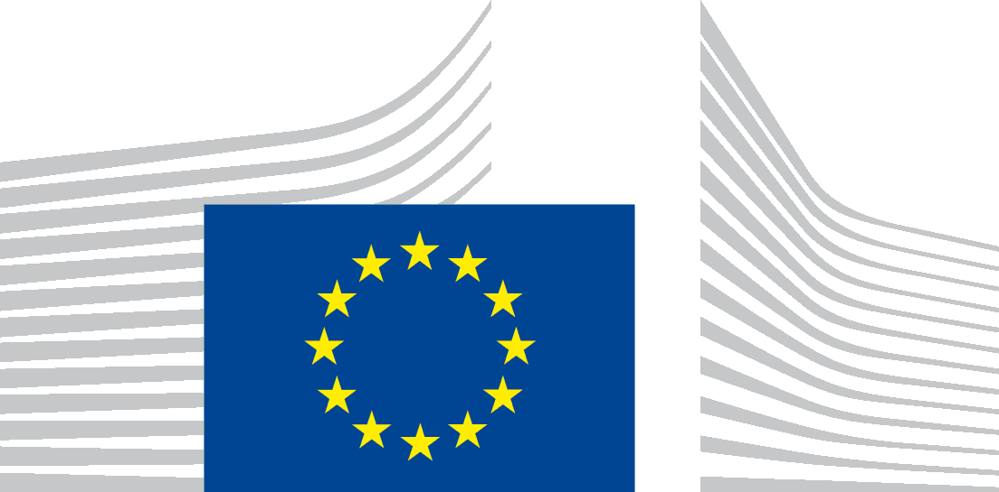 | EUROPEAN COMMISSION  DIRECTORATE-GENERAL DEFENCE INDUSTRY AND SPACE  The Director-General
Brussels
DEFIS.01/LVDP
Subject: Your application to the Commission Expert Group on policies and programmes relevant to EU Space, Defence and Aeronautics industry

Dear Mr Milan Šnajder,
I would like to thank Defence and Security Association of the Czech Republic for the interest in being part of the Commission Expert Group on policies and programmes relevant to EU Space, Defence and Aeronautics industry (“the Expert Group”).
DG DEFIS received over 120 applications by candidate organisations. This is a very encouraging sign of the dynamism and participation of the ecosystem, and it is our firm intention to build on it and create channels of transparent communication between the European Commission and the ecosystem. One of these channels will be the Expert Group. In selecting its members, DG DEFIS aimed at ensuring not only a high level of expertise, but also a balanced representation of relevant know how and areas of experience. In accordance with the rules for Commission expert groups, DG DEFIS also sought, as far as possible, an adequate geographical balance.
I am happy to appoint Defence and Security Association of the Czech Republic as a member of the Expert Group in subject. We noted the information that you provided us with, that Defence and Security Association of the Czech Republic is registered in the Transparency Register under number 028884443137-14. Please, care that this registration remains valid along the 5 year duration of your organisation mandate, as this is requirement to be member of the Expert Group.
In compliance with the horizontal rules on the creation and operations of Commission expert groups, the membership of the Expert Group will be published in the Register of Commission expert groups and other similar entities (europa.eu).
On top of the work of the Expert Group, a continuous and inclusive dialogue on the challenges and opportunities in the domains of space, defence and aeronautics industries is very important. This is why we are reflecting on ways to complement the Expert Group’s consultation with other stakeholders’ consultation initiatives, such as a workshop with all applicants to the recent call. My services will keep you informed about developments, and would of course welcome your participation and contribution in that framework as well.
I would like to inform you that the first meeting of the Expert group should take place on Friday, 10 September 2021. Please already save the date in your agenda. However, this constitutes no commitment from the Commission and you should refrain from making any arrangement before you receive the official invitation with meeting details in due course through the Advanced Gateway to your Meetings (AGM) portal.
Should you have any questions in relation to the Expert Group, do not hesitate to contact DEFIS-SDA-EG@ec.europa.eu.
I look forward to your contribution and active participation in the Expert Group.
Yours faithfully,
Electronically signed
Timo PESONEN

Commission Decision C(2016)3301.
What is AGM | Advanced Gateway to your Meetings (europa.eu)

